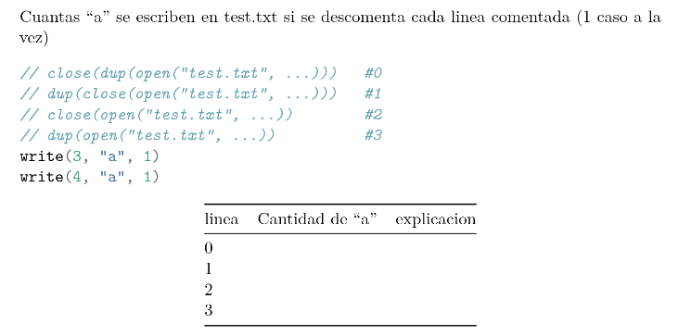

dup(fd, 1) redirecciona la salida fd a 1(stdout)

#0

open crea fd 3

dup(3) crea fd4

close cierra el ultimo fd (4)

escribe 1 a

#1

open - fd2

close fd3

dup tira error

a = 0

#2

a = 0

#3

open fd 3

dup fd 4

a = 2